Informatio

- CTF Name: OWASP-Juice-Shop

- CTF Level: 10

- Description This room uses the Juice Shop vulnerable web application to learn how to identify and exploit common web application vulnerabilities.

- Date: 8/25/2024

- Platform: tryHackme

- IP: 10.10.129.81

Geez Security evaluated the OWASP Juice Shop on TryHackMe revealed critical vulnerabilities that could severely impact an organization's security posture. By addressing these vulnerabilities promptly and implementing the recommended actions, organizations can significantly enhance their security defenses, protect sensitive information, and maintain stakeholder confidence.

Geez Security evaluated owasp juice shop ’s external security posture through an external network penetration test from 9/25/2024 to 9/26/2024. By leveraging a series of attacks, Geez Security found critical level vulnerabilities that allowed *full internal network access* to the office. It is highly recommended that.

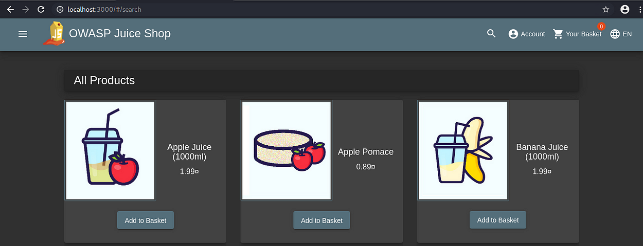

refer: <https://github.com/bkimminich/juice-shop>

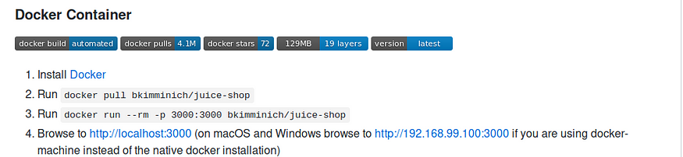

**How to access score-board?  
Solution:**localhost:3000/#/score-board

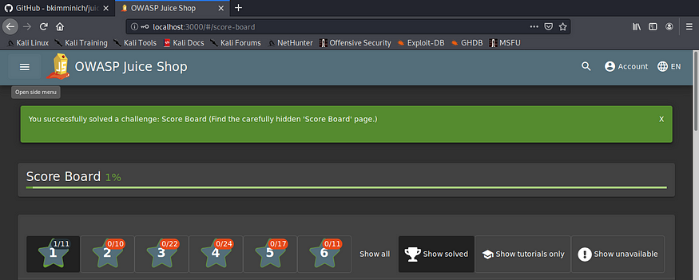

**How to check Error Handling on login ?**  
Solution: SQL injection: put singele quote in both email and password)

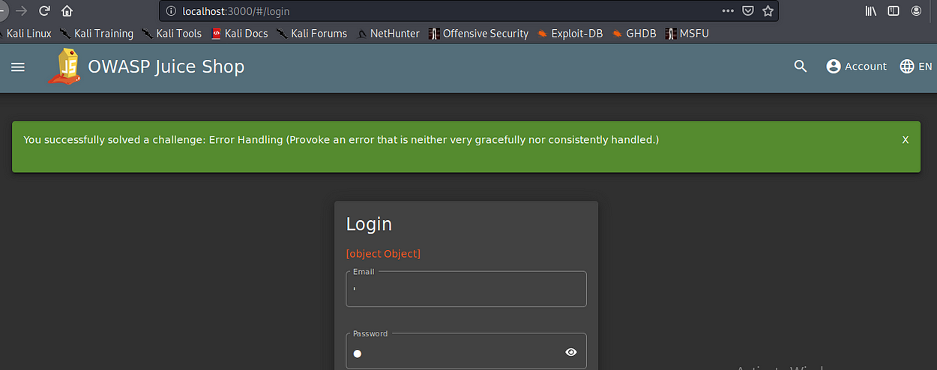

Name: Confidential document

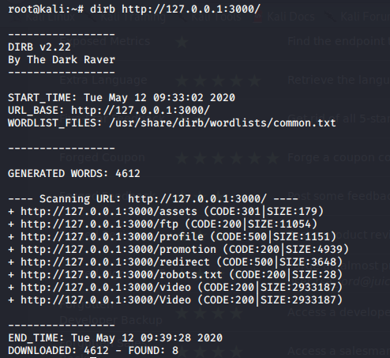

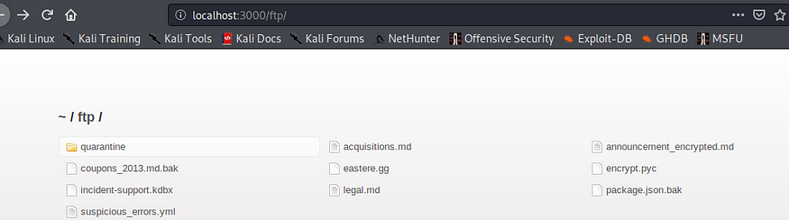

Open <http://localhost:3000/ftp/acquisitions.md> to solve the challenge.

I try to click and download all file to see data inside but some file when click,it redirect to error.So,I try to search about Local File Inclusion(LFI).I found LFI null byte can use both %00 and %2500 but in this case %00 not works.So,I try %2500 and then i can download file

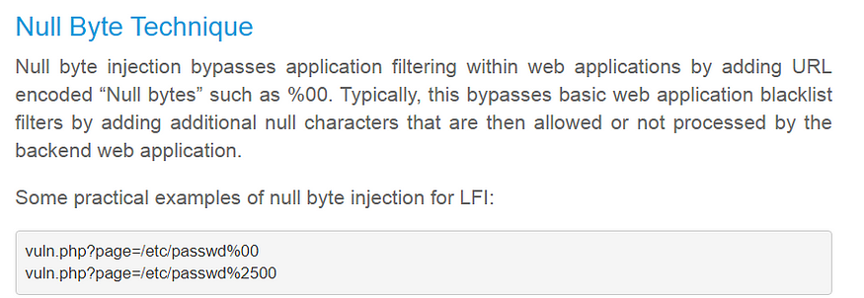

from <https://hakin9.org/web-application-penetration-testing-local-file-inclusion-lfi-testing/>

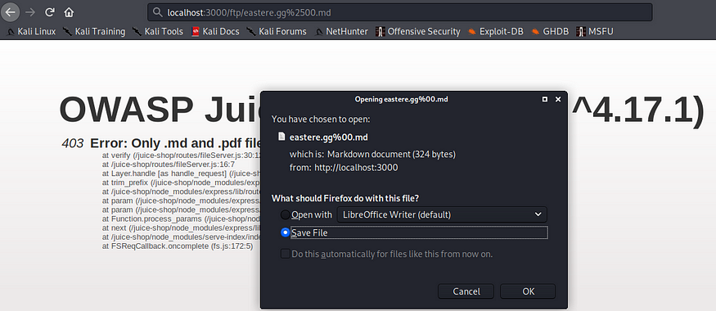

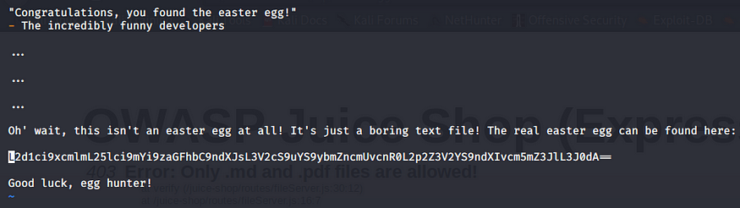

i see ‘==’ and the end.I know suddenly it is format of base64  
I try decode it via command line and try put result on browser but not work



So, I search multi decode on google because I not know this format and found this website: <http://fbcs.bplaced.net/multi_encoder_decoder.html>

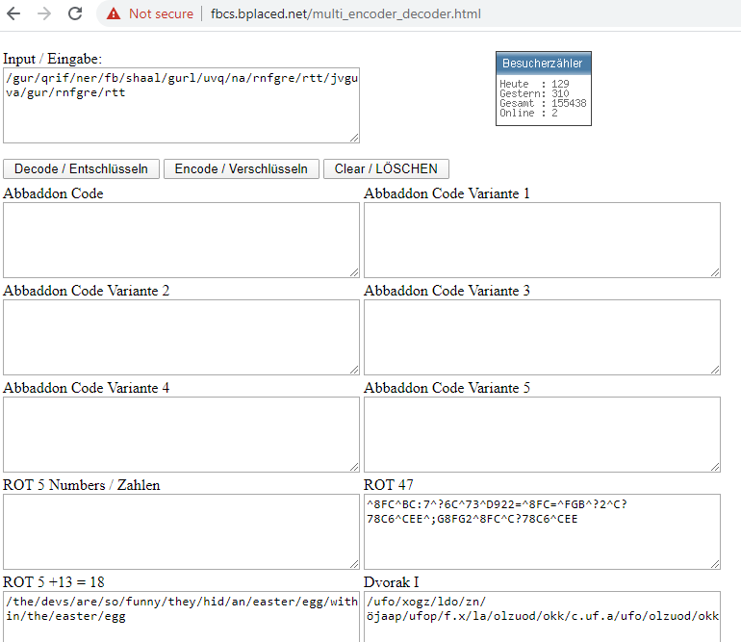

the result on ROT 5+13 look like human readable.So, I try localhost:3000/the/devs/are/so/funny/they/hid/an/easter/egg/within/the/easter/egg on browser again and this time pass !!



Okays, I try technique LFI null byte same %%2500 again with **coupons_2013.md.bak**and **package.json.bak**for download all files

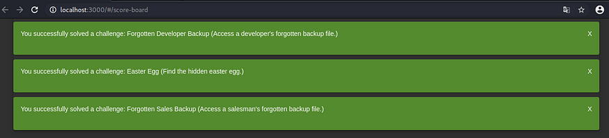

**How to check weird crypto?**

After I download file **package.json.bak**, I can see all library that developer use.So,i try sent library name in Customer Feedback and found it is z85

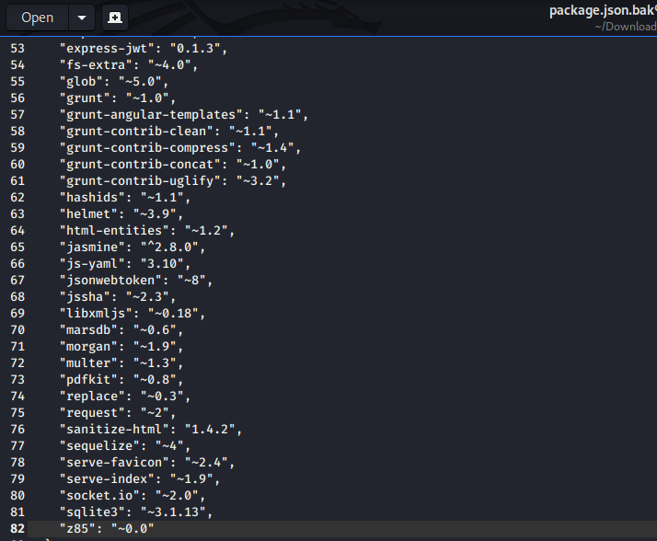

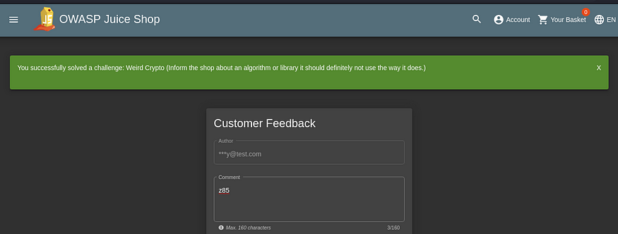

**How to log in as support user?**  
I notice file in ftp path.It has **incident-support.kdbx**.I try check format file kbdx on google and found it use with Keepass

“KeePass can generate key files for you, however you can also use any other, already existing file (like JPG image, DOC document, etc.). In order to use an existing file as key file” — from Keepass page

From definition,it means it can use file type image as key for open file.So, i go to About us page on juice shop and try check files one by one

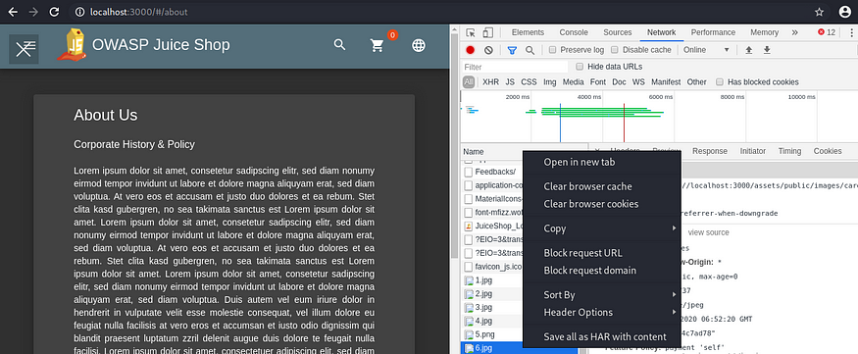

Click open in new tab and then download 6.jpg

Open file incident-support.kbdx,it will pop-up ask for Key File

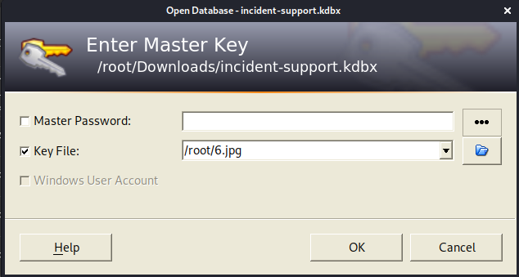

Now we can see support user in incident-support.kbdx

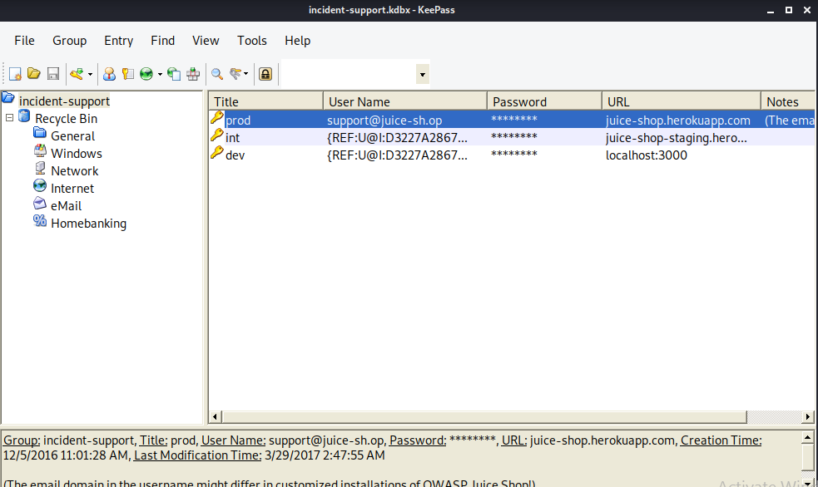

right clicp on support@juice-sh.op and click ‘edit entry’ and then show password

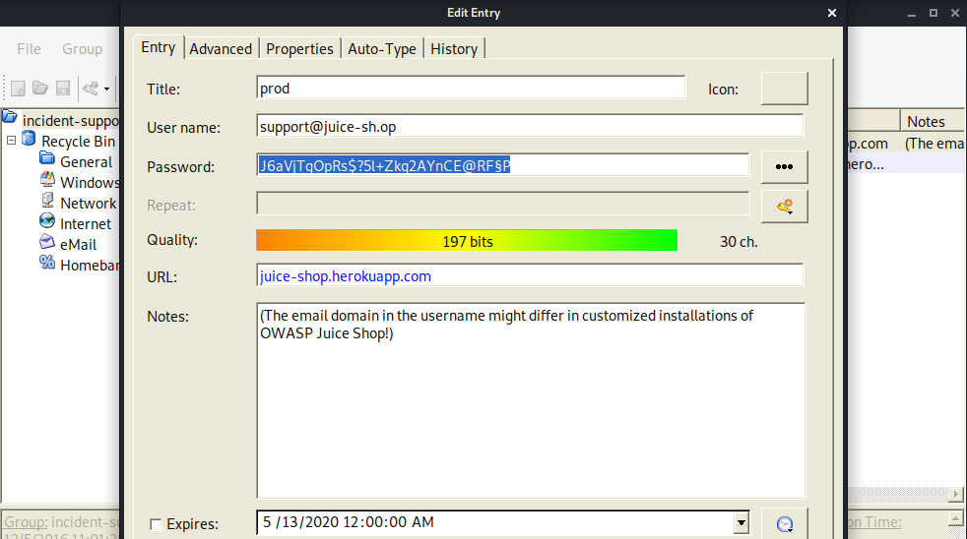

Try login as support user

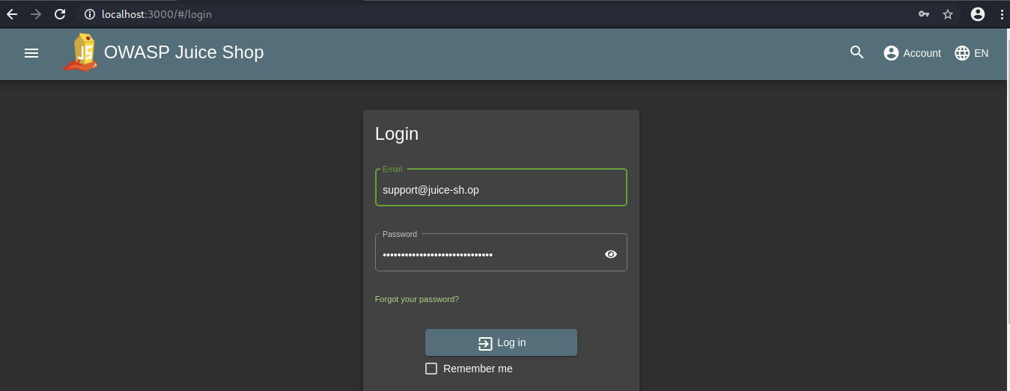

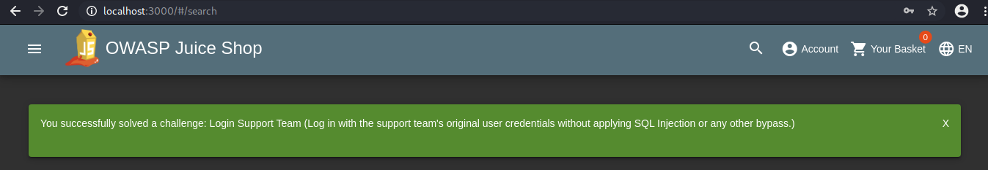

Name: DOM XSS  
(put <iframe src=”javascript:alert(`xss`)”> in search)

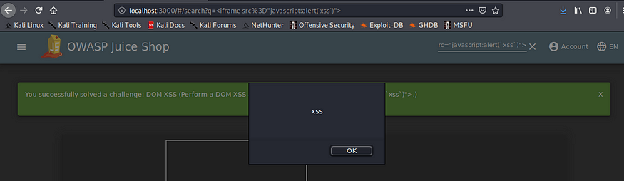

Name: Zero Stars

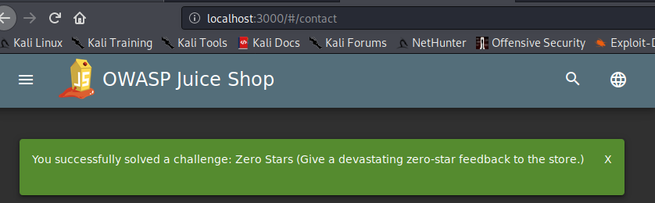

I inspect html at ‘Submit’ button.I noticed when not select star..button will disable.So, i **delete word disable true** out and then button turn to be enable and can put Submit without any star score

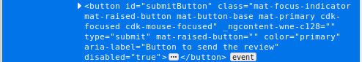

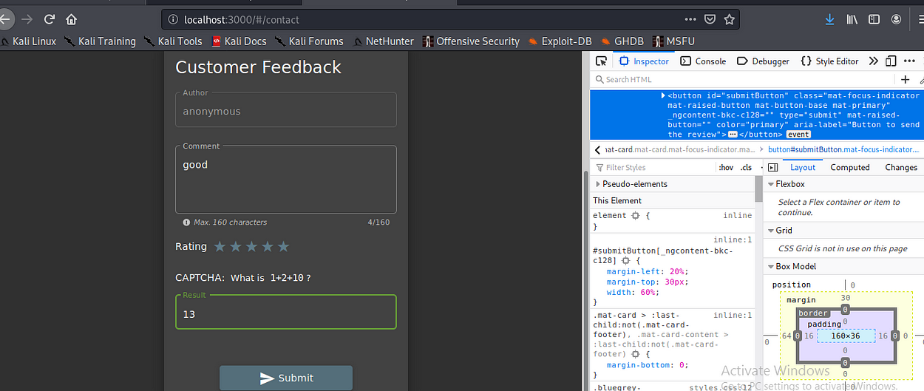

**Name: Login Admin** (login both username, password with ‘ or 1=1 — )

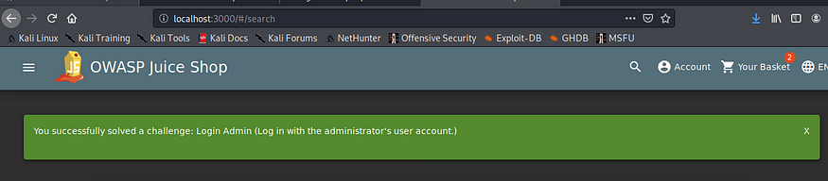

**Name: Privacy Policy**  
(After login, click on Account > Privacy & Security > Privacy Policy)

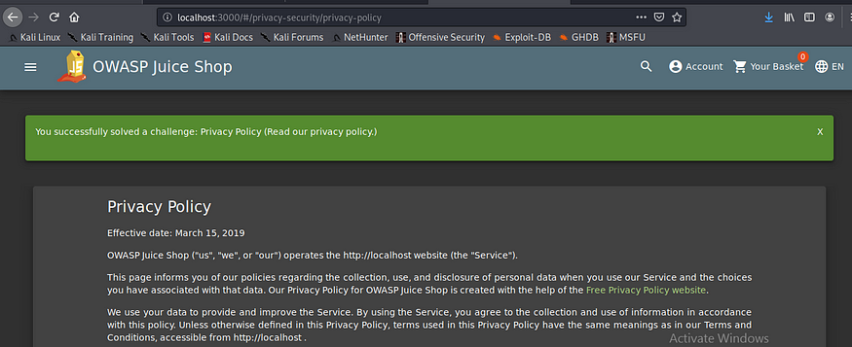

**Name: Provacy Policy Inspection**  
(Find all word that use <span class= “hot”> and then concat all word together to be <http://localhost:3000/we/may/also/instruct/you/to/refuse/all/reasonably/necessary/responsibility> )

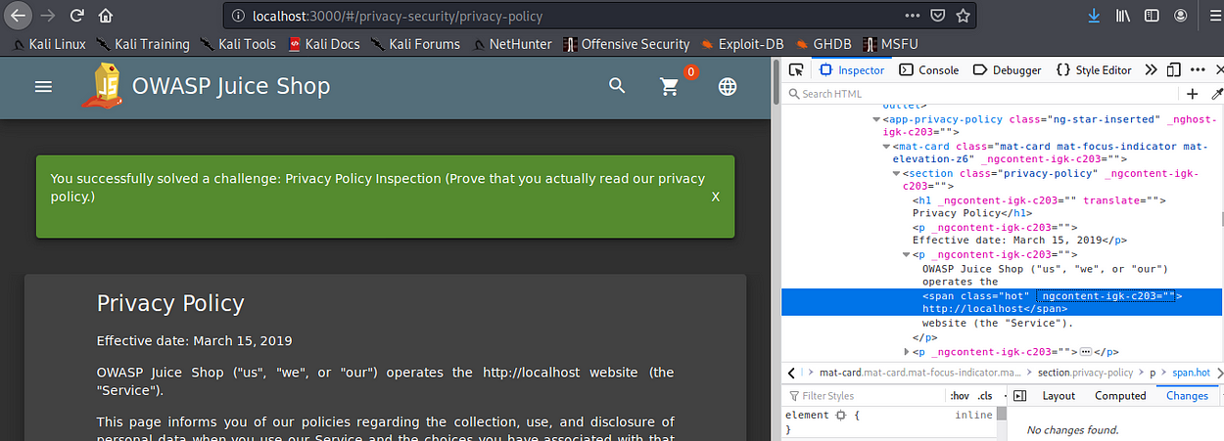

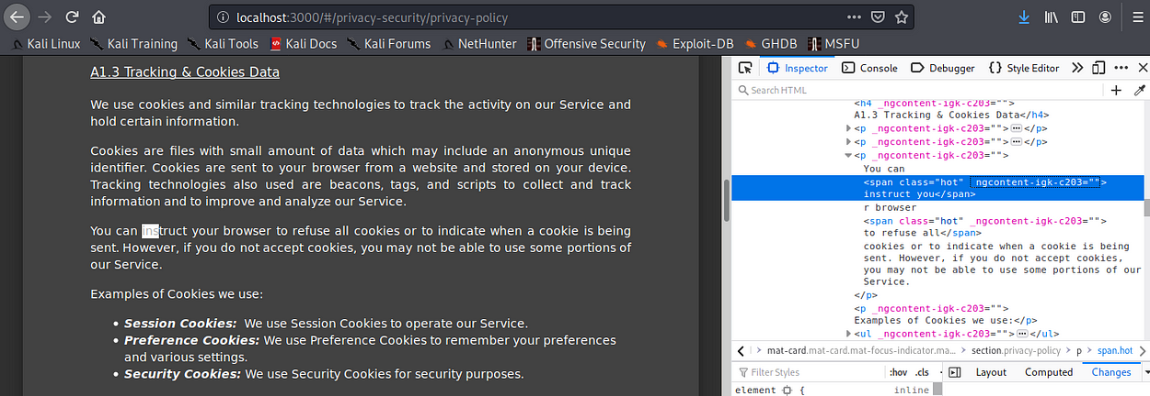

**How to log in as admin with password?**

I try to check ..Can I bruteforce password on localhost via bruteforce in intruder mode on Burpsuit?

**This is how to setting proxy to allow on localhost for Burpsuit**

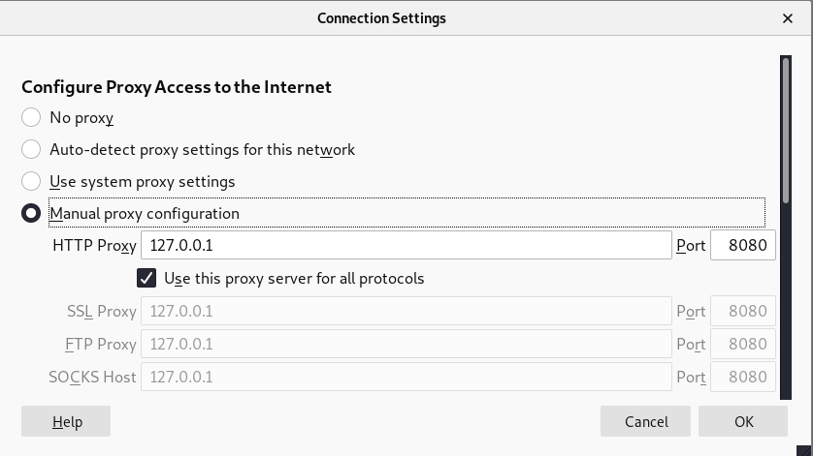

Set proxy port to be 8080

Open about:config on browser and Click Accept risk

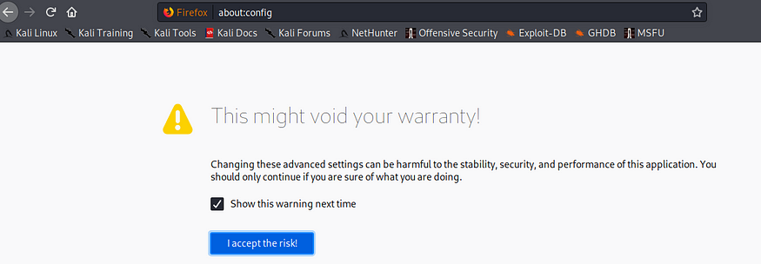

Search **network.proxy.allow** and double click on Value to change from false to be true



Try login page with username and password admin,admin  
Be sure on Burpsuit is ‘Intercept on’ before hit ‘Log in’ button

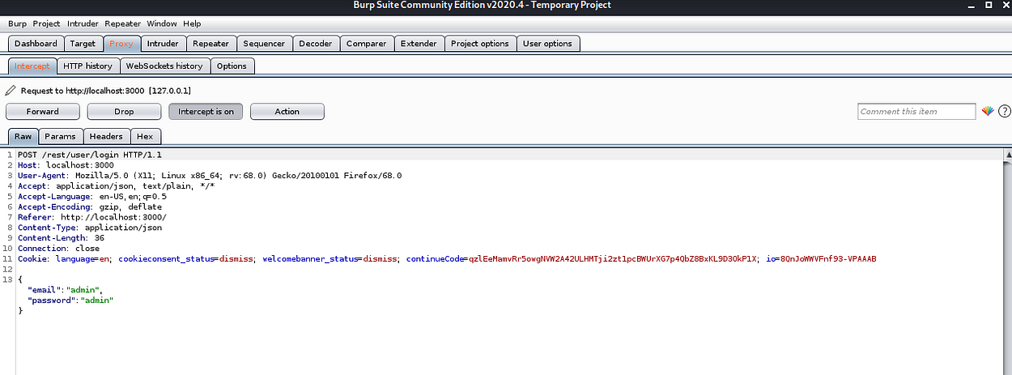

Right click on area and select ‘sent to intruder’ and then go to tab ‘intruder’  
highlight username and password value and click ‘add’ button

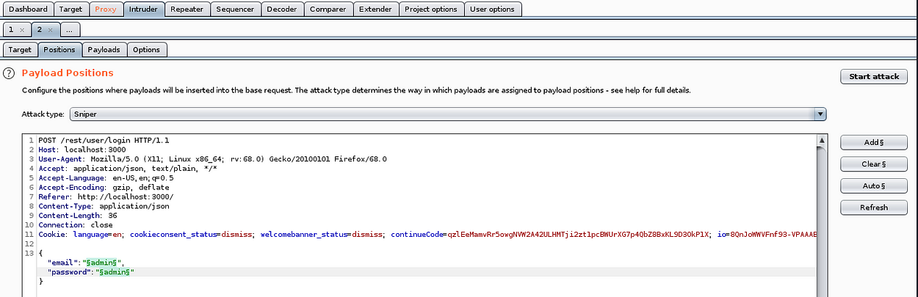

Clone https://github.com/swisskyrepo/PayloadsAllTheThings and put folder PayloadsAllThings in /usr/share/wordlist on kali and then load file in Payload option select Auth_Bypass2.txt

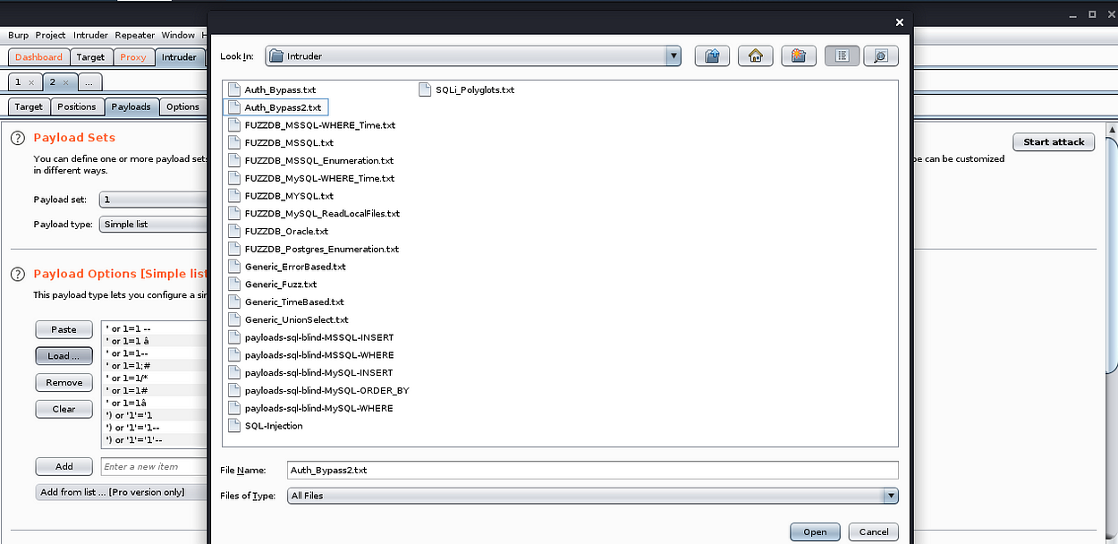

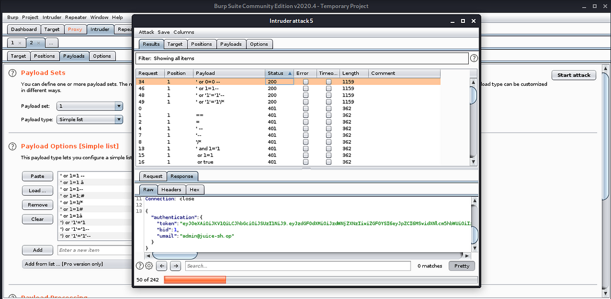

Highligh token value and right click choose ‘sent to decode’

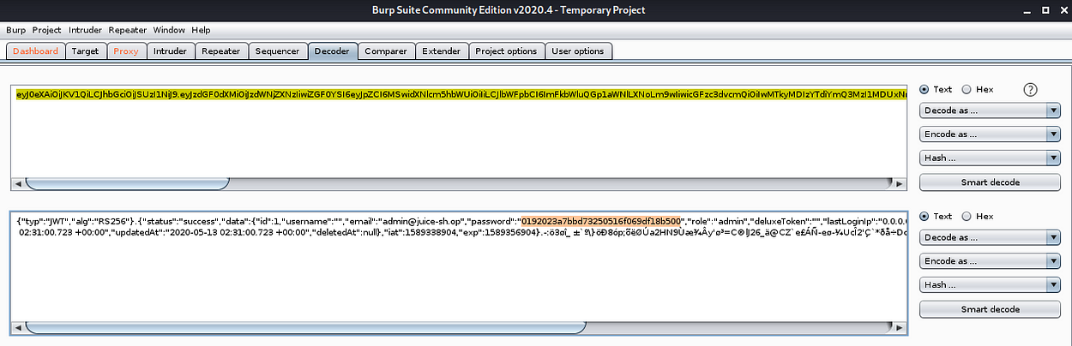

Decode as Base64 to text

Bring password value to check type hash in hash-dentifier and found it is md5

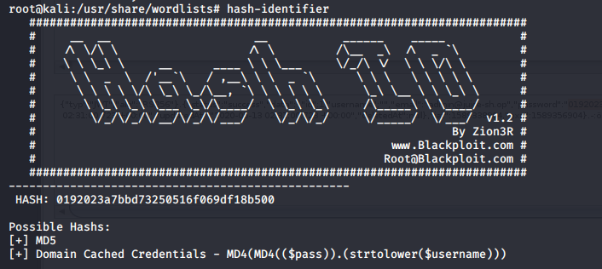

Save password hash into file admin.txt and then use hashcat crack password  
hashcat -m 0 -a 0 admin.txt /usr/share/wordlists/rockyou.txt —

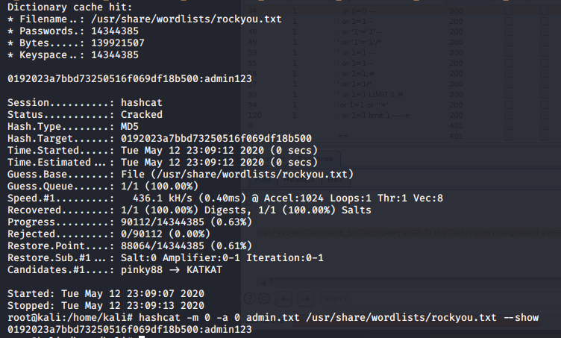

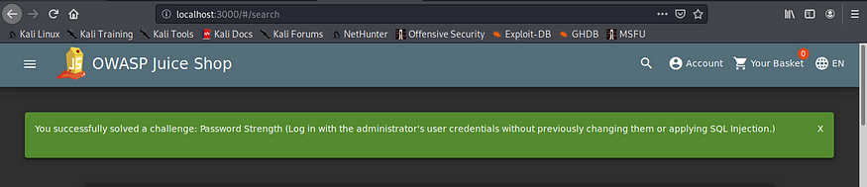

Try inspect on network tab and found

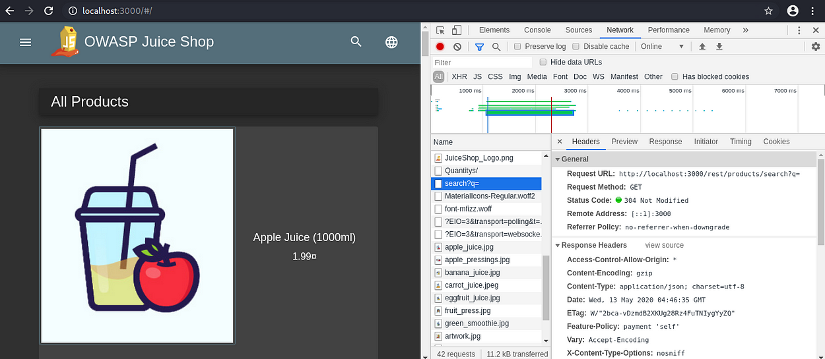

from Request URL that we inspect network on chrome browser, we get idea how to sqlmap find table name from owasp juice shop

*sqlmap -u “http://localhost:3000/rest/products/search?q=” -D localhost — tables — level=5 — batch*

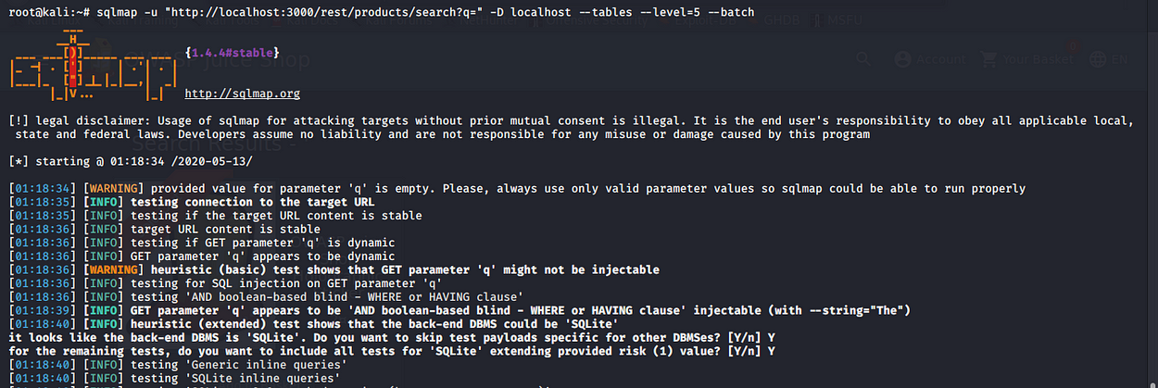

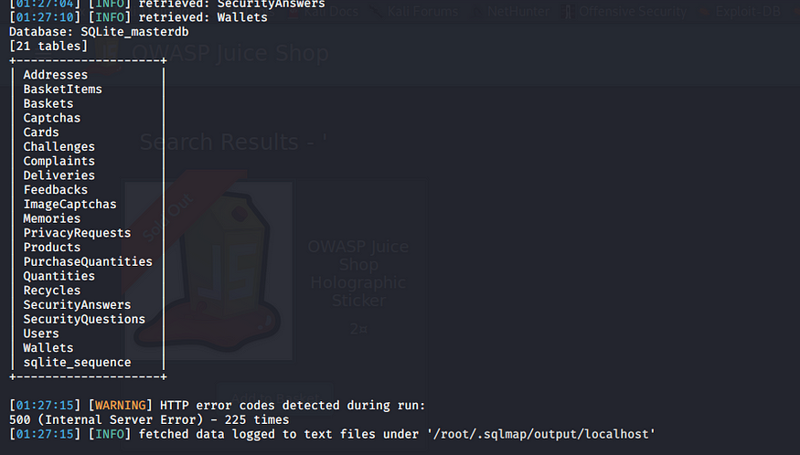

I try to retrieve Users table from sqlmap but it not works

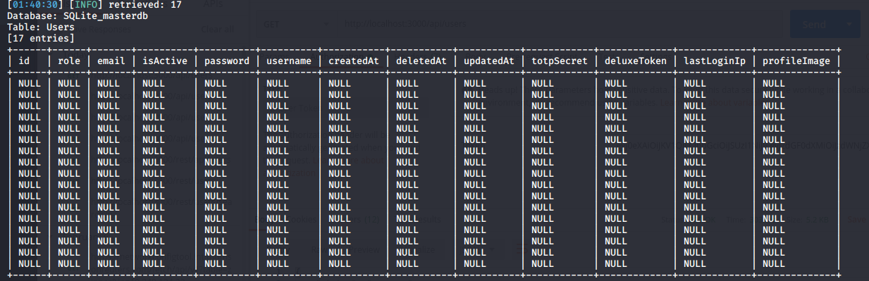

So, I try anotherway. I noticed on browser that i inspect url request.Pattern urls that I saw is localhost/rest/… or localhost/api/… so,i try similar path on postman to see users data.

1. http://localhost:3000/rest/api/users  
   It response back : Error: Unexpected path: /rest/api/users
2. http://localhost:3000/rest/users  
   Error: Unexpected path: /rest/users
3. http://localhost:3000/api/users  
   UnauthorizedError: No Authorization header was found

It means this path works !! It need Authorization token in api.So, I try log in as admin again and check on ‘whoami’ and I saw it use Authorization Bearer Token and this token.We already have since first time try sql injection bruteforce for log in via Burpsuit

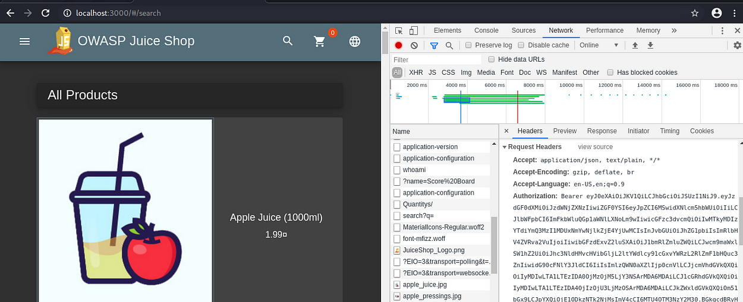

Put token admin in Postman API, we will see now we can list all users in juice shop but important data look like to be only email and role ..no password

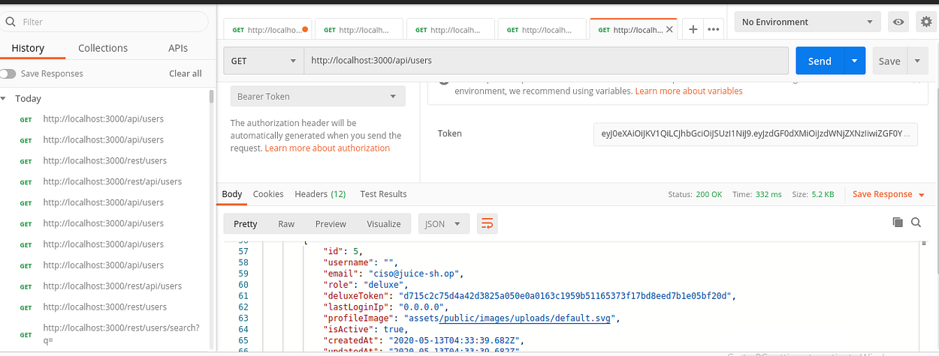

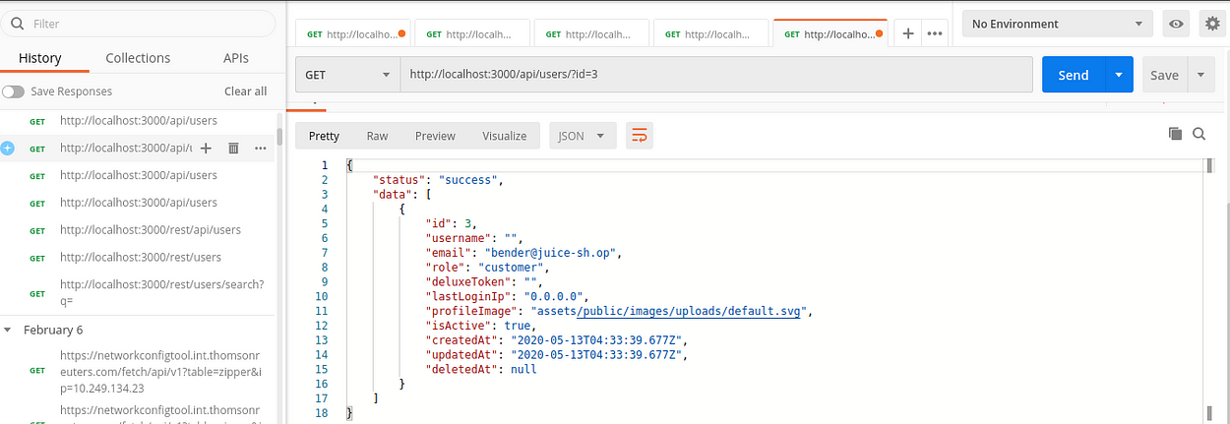

I try to bruteforce password bender with most common password via burpsuit but not found valid password for login.So,I try sql injection on username use  
**bender@juice-sh.op’; —**and password log in

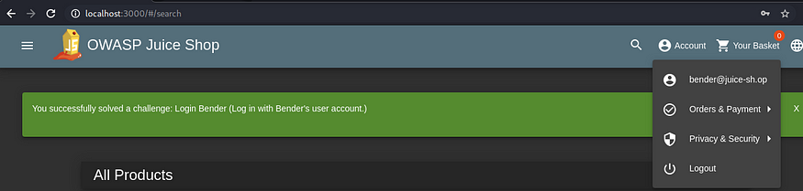

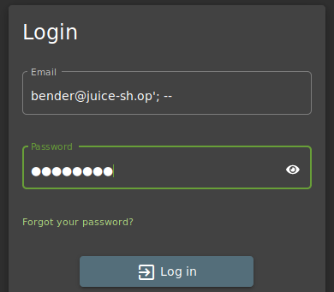

I try to change password without know current password but it said illegal

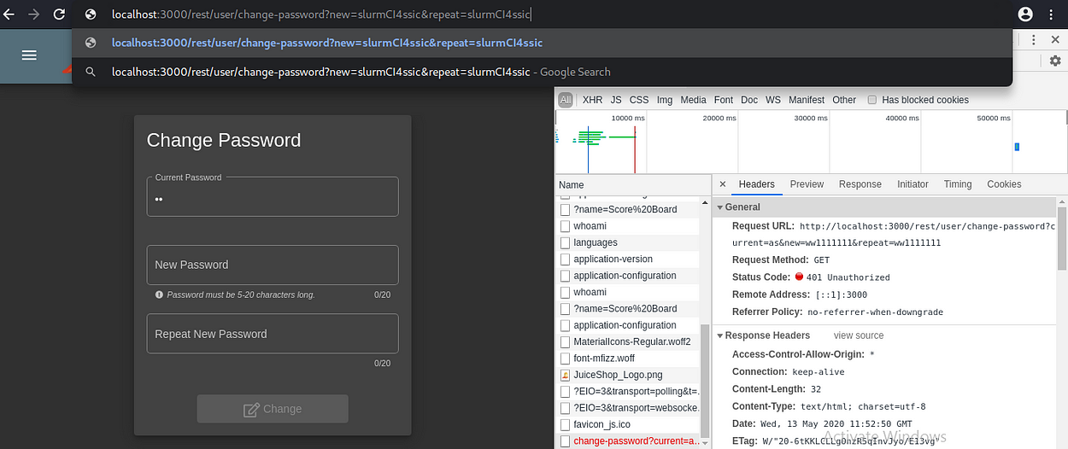

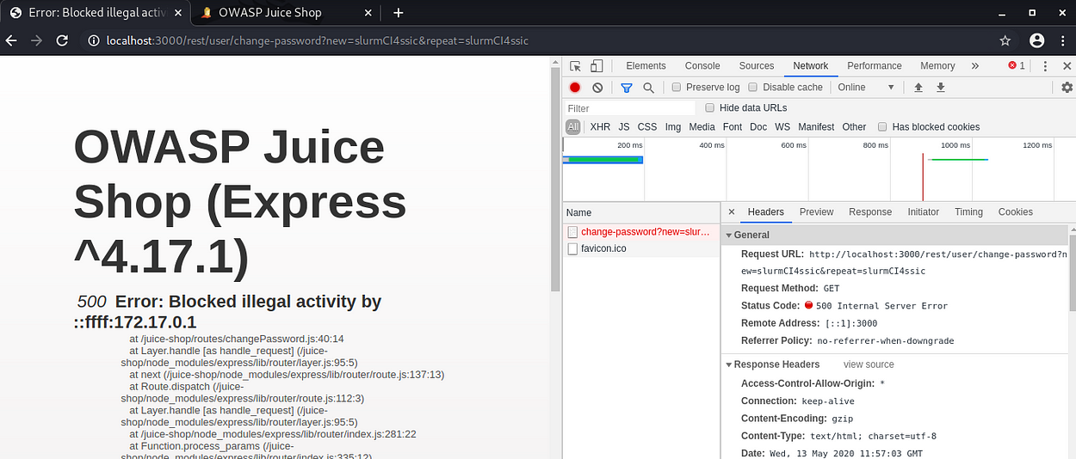

**How to see view Other basket?**

**Solution:** I login as test@test.com on chrome browser and order Apple

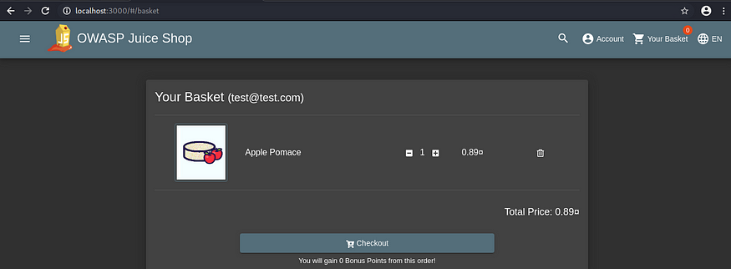

and browser firefox,login as ploy@test.com and open same url.I saw order from test user in my basket

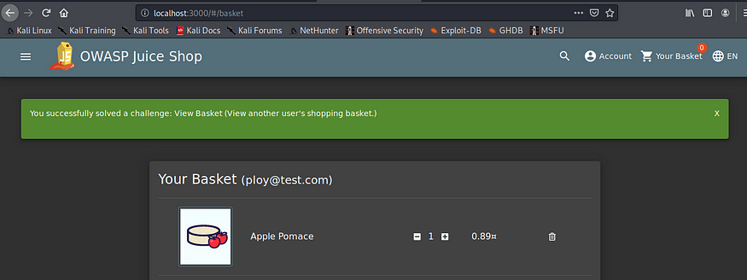

**How to see Metrics data usage on server?**

For example prometheus, path /metric is default path to see data



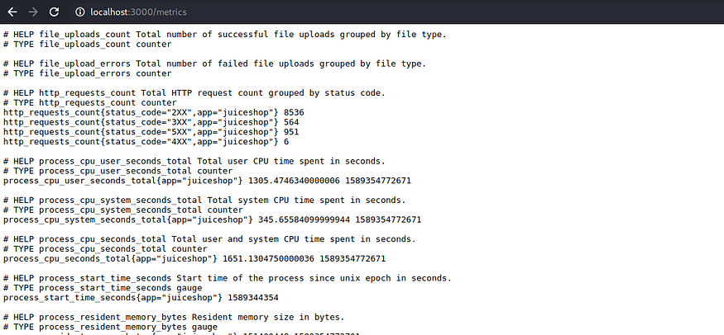

**How to access log on server?**

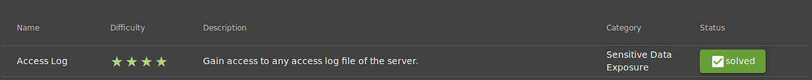

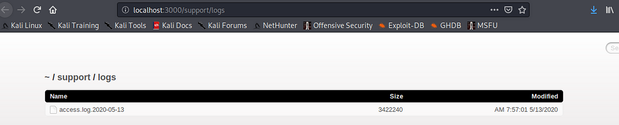

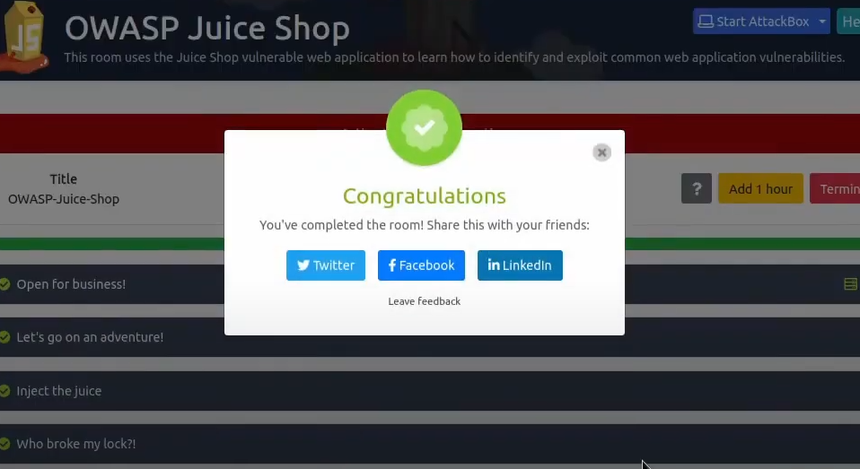

**Finding Description   
Severity Rating**

**Weak Authentication**

**Cross-Site Scripting (XSS)**

**Insecure Direct Object References (IDOR)**

**Sensitive Data Exposure**

**Business Logic Flaws**

**SQL Injection Vulnerability**

**nsecure File Upload**

**Missing Security Headers**

**The application allowed the use of weak passwords and lacked account lockout mechanisms.**

**Multiple input fields were vulnerable to XSS attacks, enabling attackers to execute scripts.**

**Users could manipulate URLs to access unauthorized resources, breaching data confidentiality.**

Vulnerabilities are non-exploitable but would reduce an organization’s attack surface. It is advised to form a plan of action and patch during the next maintenance window.

**User credentials were found to be transmitted without encryption, increasing the risk of interception.**

**Certain workflows could be exploited to gain unauthorized access to features or data.**

**The application was susceptible to SQL injection, allowing attackers to manipulate database queries.**

The application did not implement essential security headers, increasing vulnerability to attacks.

**File upload functionality did not adequately validate file types, leading to potential application compromise.**

**High**

**High**

**Critical**

**High**

|  |
| --- |
| **Medium** |
| **Medium** |

| **Severity Rating** |
| --- |
| **Weak Authentication** | The application allowed the use of weak passwords and lacked account lockout mechanisms. | **High** |
| **Cross-Site Scripting (XSS)** | Multiple input fields were vulnerable to XSS attacks, enabling attackers to execute scripts. | **High** |
| **Insecure Direct Object References (IDOR)** | Users could manipulate URLs to access unauthorized resources, breaching data confidentiality. | **Critical** |
| **Sensitive Data Exposure** | User credentials were found to be transmitted without encryption, increasing the risk of interception. | **High** |
| **Business Logic Flaws** | Certain workflows could be exploited to gain unauthorized access to features or data. | **Medium** |
| **SQL Injection Vulnerability** | The application was susceptible to SQL injection, allowing attackers to manipulate database queries. | **Critical** |
| **Missing Security Headers** | The application did not implement essential security headers, increasing vulnerability to attacks. | **Medium** |
| **Insecure File Upload** | File upload functionality did not adequately validate file types, leading to potential application compromise. | **High** |

**Assessment Scope**

**The scope of the assessment was defined to ensure comprehensive coverage of the application's security features and vulnerabilities. The following components were included:**

Scope of Assessment:

The assessment of the OWASP Juice Shop aimed to identify vulnerabilities within the application and evaluate its overall security posture. The following table outlines the key components included in the assessment scope.

| **Scope Component** | **Description** |
| --- | --- |
| **Web Application Functionality** | Examination of all user interfaces, including features such as product browsing, shopping cart, and user registration. |
| **API Endpoints** | Evaluation of RESTful APIs for security vulnerabilities, including data access and manipulation. |
| **Authentication Mechanisms** | Review of user login and registration processes, focusing on password policies and session management. |
| **Access Controls** | Analysis of user roles and permissions to ensure appropriate access restrictions are in place. |
| **Input Validation** | Testing of all user input fields to identify potential injection vulnerabilities, such as SQL injection and XSS. |
| **Error Handling** | Review of application error messages to ensure they do not reveal sensitive information. |
| **Sensitive Data Handling** | Investigation of how sensitive information (e.g., passwords, personal data) is stored and transmitted. |
| **Compliance with OWASP Top Ten** | Alignment with the OWASP Top Ten vulnerabilities to assess the application against industry-standard security risks. |
| **Security Headers** | Evaluation of security headers in HTTP responses to enhance protection against common attacks. |

**Technical Details of Vulnerabilities:**

| **Vulnerability** | **Description** | **Impact** | **Exploit Scenario** | **Remediation Recommendations** |
| --- | --- | --- | --- | --- |
| **Weak Authentication** | **The application allows weak password choices and lacks account lockout mechanisms.** | **Unauthorized access to user accounts could lead to data breaches and account takeovers.** | **An attacker could use a brute-force attack to guess weak passwords and gain access to accounts.** | **Implement strong password policies and account lockout after failed attempts.** |
| **Cross-Site Scripting (XSS)** | **User input fields do not properly sanitize or validate input, making them vulnerable to XSS.** | **Attackers can execute scripts in the context of another user's session, potentially stealing cookies or performing actions on behalf of the user.** | **An attacker could inject a malicious script into a comment field, which gets executed when another user views the comment.** | **Implement input validation and output encoding to prevent XSS.** |
| **Insecure Direct Object References (IDOR)** | **URL parameters allow users to access resources they are not authorized to view.** | **Sensitive data exposure, leading to privacy breaches and unauthorized access to other users' information.** | **An attacker could modify a URL parameter to access another user's account details or resources.** | **Implement proper authorization checks before allowing access to resources.** |
| **Sensitive Data Exposure** | **Sensitive information, including user credentials, is transmitted without encryption.** | **Interception of data in transit could lead to unauthorized access and data breaches.** | **An attacker could use a man-in-the-middle attack to intercept unencrypted credentials during transmission.** | **Use HTTPS for all data transmission and encrypt sensitive data at rest.** |
| **SQL Injection Vulnerability** | **The application does not properly validate SQL queries, allowing for SQL injection attacks.** | **Attackers can manipulate database queries, potentially leading to data leaks, modification, or deletion.** | **An attacker could input a crafted SQL command in a search field to extract sensitive data from the database.** | **Use parameterized queries or ORM frameworks to prevent SQL injection.** |
| **Missing Security Headers** | **The application does not implement essential HTTP security headers.** | **Increased vulnerability to various attacks, including XSS, clickjacking, and content type sniffing.** | **An attacker could exploit the absence of security headers to perform attacks that compromise user data.** | **Implement security headers like Content Security Policy and X-Content-Type-Options.** |
| **Insecure File Upload** | The file upload functionality lacks proper validation of file types and content. | Potential for uploading malicious files, which could lead to server compromise or execution of arbitrary code. | An attacker could upload a malicious script disguised as an image file, leading to server exploitation. | Validate file types and contents, and implement strict upload restrictions. |
| **Information Disclosure via Error Messages** | Error messages provide detailed information about the application and its environment. | Detailed error messages can aid attackers in crafting targeted attacks on the application. | An attacker could trigger an error to gather information about the application's structure or technologies used. | Implement generic error messages that do not disclose sensitive information. |
|  |  |  |  |  |

## Vulnerability Details Table

| **Vulnerability** | **Description** | **Impact** | **Exploit Scenario** | **Remediation Recommendations** |
| --- | --- | --- | --- | --- |
| **Weak Authentication** | The application allows weak password choices and lacks account lockout mechanisms. | Unauthorized access to user accounts could lead to data breaches and account takeovers. | An attacker could use a brute-force attack to guess weak passwords and gain access to accounts. | Implement strong password policies and account lockout after failed attempts. |
| **Cross-Site Scripting (XSS)** | User input fields do not properly sanitize or validate input, making them vulnerable to XSS. | Attackers can execute scripts in the context of another user's session, potentially stealing cookies or performing actions on behalf of the user. | An attacker could inject a malicious script into a comment field, which gets executed when another user views the comment. | Implement input validation and output encoding to prevent XSS. |
| **Insecure Direct Object References (IDOR)** | URL parameters allow users to access resources they are not authorized to view. | Sensitive data exposure, leading to privacy breaches and unauthorized access to other users' information. | An attacker could modify a URL parameter to access another user's account details or resources. | Implement proper authorization checks before allowing access to resources. |
| **Sensitive Data Exposure** | Sensitive information, including user credentials, is transmitted without encryption. | Interception of data in transit could lead to unauthorized access and data breaches. | An attacker could use a man-in-the-middle attack to intercept unencrypted credentials during transmission. | Use HTTPS for all data transmission and encrypt sensitive data at rest. |
| **SQL Injection Vulnerability** | The application does not properly validate SQL queries, allowing for SQL injection attacks. | Attackers can manipulate database queries, potentially leading to data leaks, modification, or deletion. | An attacker could input a crafted SQL command in a search field to extract sensitive data from the database. | Use parameterized queries or ORM frameworks to prevent SQL injection. |
| **Missing Security Headers** | The application does not implement essential HTTP security headers. | Increased vulnerability to various attacks, including XSS, clickjacking, and content type sniffing. | An attacker could exploit the absence of security headers to perform attacks that compromise user data. | Implement security headers like Content Security Policy and X-Content-Type-Options. |
| **Insecure File Upload** | The file upload functionality lacks proper validation of file types and content. | Potential for uploading malicious files, which could lead to server compromise or execution of arbitrary code. | An attacker could upload a malicious script disguised as an image file, leading to server exploitation. | Validate file types and contents, and implement strict upload restrictions. |
| **Information Disclosure via Error Messages** | Error messages provide detailed information about the application and its environment. | Detailed error messages can aid attackers in crafting targeted attacks on the application. | An attacker could trigger an error to gather information about the application's structure or technologies used. | Implement generic error messages that do not disclose sensitive information. |
|  |  |  |  |  |

## Geez Security is available for consultation and re-testing after the remediation has been implemented to ensure that the identified vulnerabilities have been properly addressed and no new risks have been introduced. Key Findings

The assessment revealed the following key vulnerabilities:

1. Weak Authentication Mechanisms: The application allowed weak passwords and lacked account lockout features, increasing the risk of unauthorized access.
2. Cross-Site Scripting (XSS): Insufficient input validation led to multiple XSS vulnerabilities, enabling potential script injection.
3. Insecure Direct Object References (IDOR): Users could manipulate URLs to access unauthorized resources, posing a significant risk of data exposure.
4. Sensitive Data Exposure: The lack of encryption for sensitive data in transit heightened the risk of interception during transmission.
5. SQL Injection Vulnerabilities: The application was susceptible to SQL injection, allowing attackers to manipulate database queries.
6. Missing Security Headers: Essential security headers were not implemented, increasing vulnerability to various attacks.
7. Insecure File Upload: The file upload functionality lacked adequate validation, allowing for potentially malicious files to be uploaded.
8. Information Disclosure via Error Messages: Detailed error messages revealed sensitive information that could aid attackers.

## Implications

The vulnerabilities identified pose significant risks to the application and its users. If left unaddressed, they could lead to unauthorized access, data breaches, and exploitation of sensitive information. The findings underscore the importance of implementing robust security practices in web applications, particularly those designed for educational purposes.

## Recommendations

To enhance the security of the OWASP Juice Shop, the following remediation strategies are recommended:

* Implement strong password policies and account lockout mechanisms.
* Utilize input validation and output encoding to mitigate XSS vulnerabilities.
* Ensure proper authorization checks are in place to prevent IDOR.
* Transmit sensitive data over secure channels (HTTPS) and encrypt data at rest.
* Use parameterized queries to protect against SQL injection.
* Implement essential security headers to provide additional layers of protection.
* Validate file uploads rigorously to prevent the upload of malicious files.
* Ensure generic error messages are used to avoid disclosing sensitive information.

## Final Thoughts

The assessment of the OWASP Juice Shop serves as a crucial learning opportunity for understanding web application security vulnerabilities. By addressing the identified weaknesses and adhering to security best practices, developers and organizations can significantly improve the security of their applications. Continuous education and awareness of emerging threats are vital in maintaining a secure application environment.